**1)Two 8 bit addition program:**

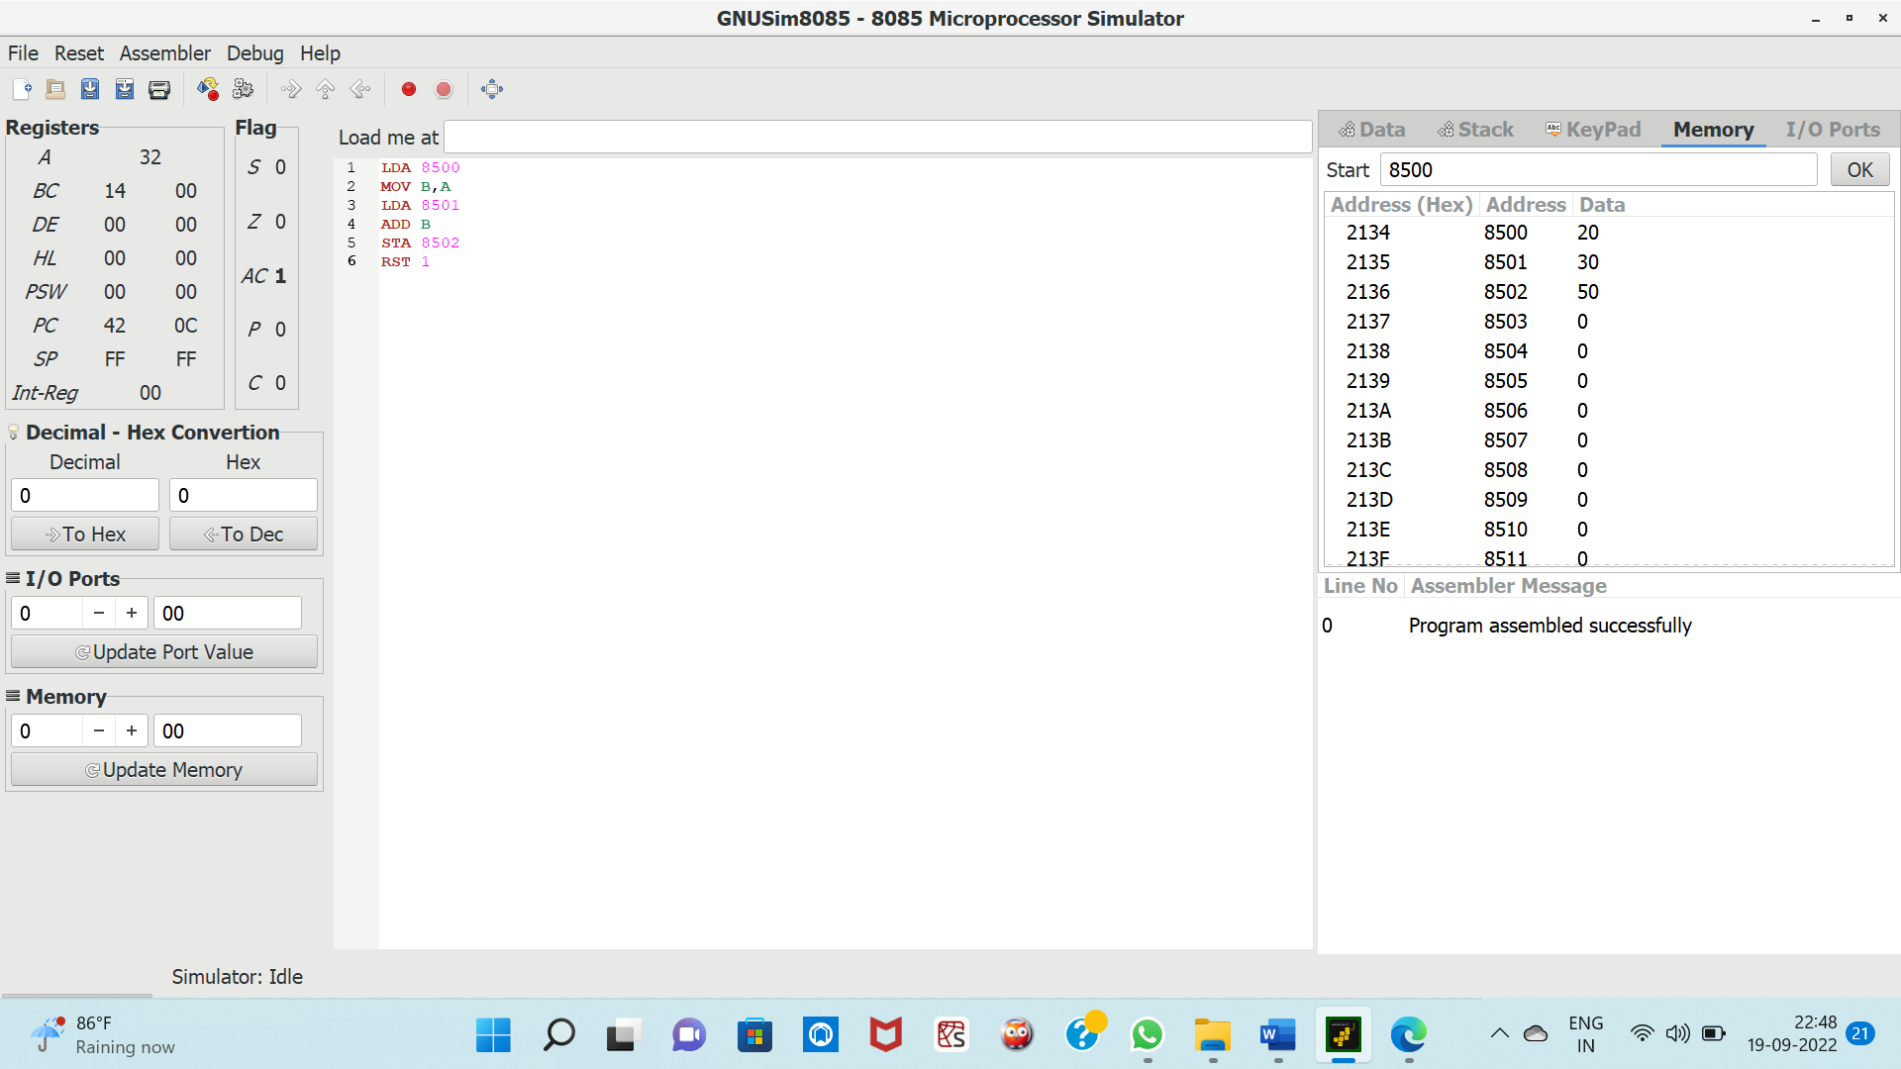

2) **Subtraction of two 8 bit numbers:**

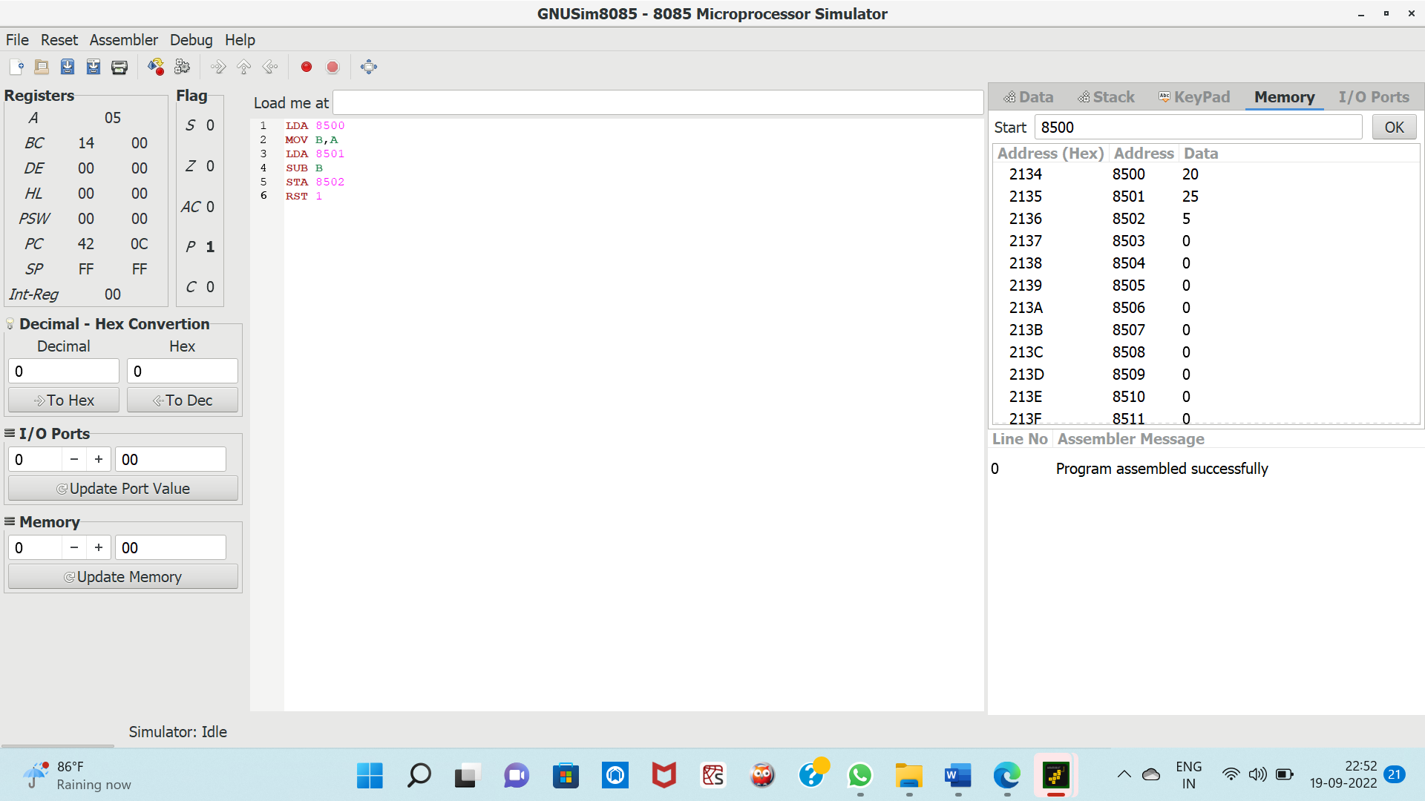

**3) Multiplication of two 8 bit numbers:**

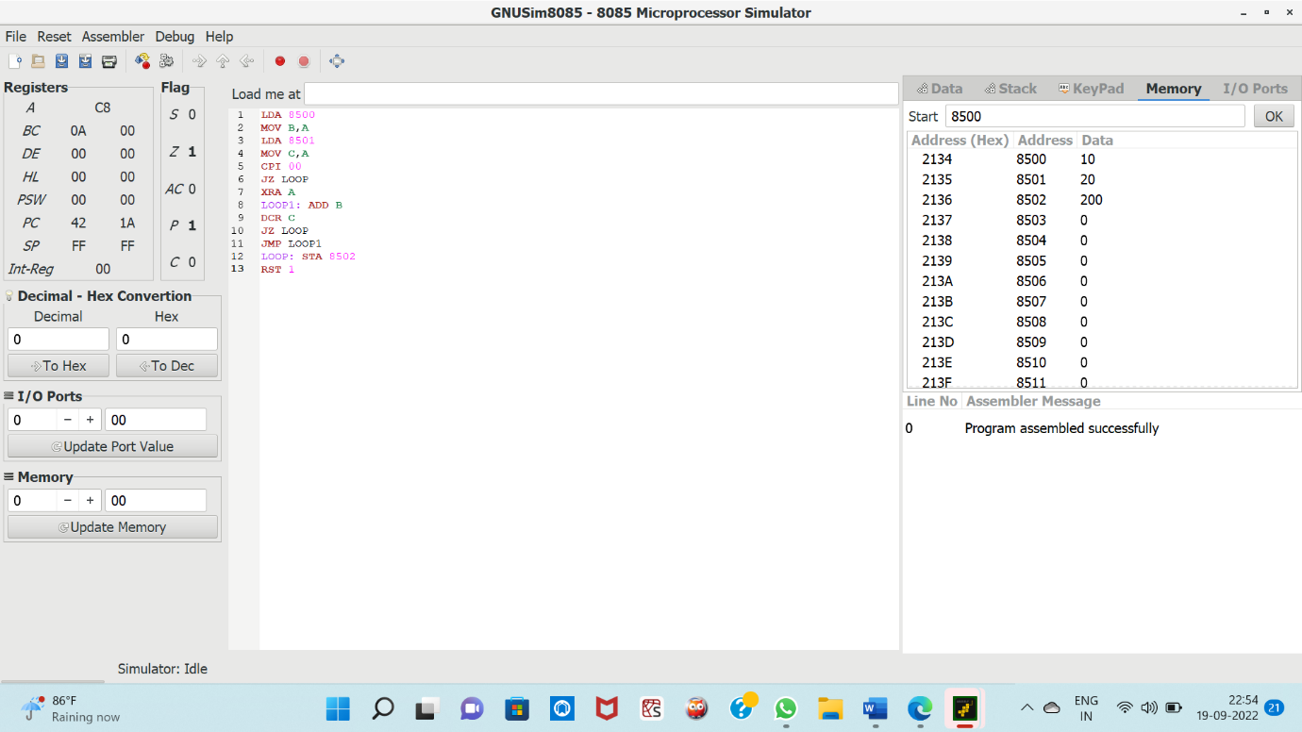

4) **Division of two 8 bit numbers:**

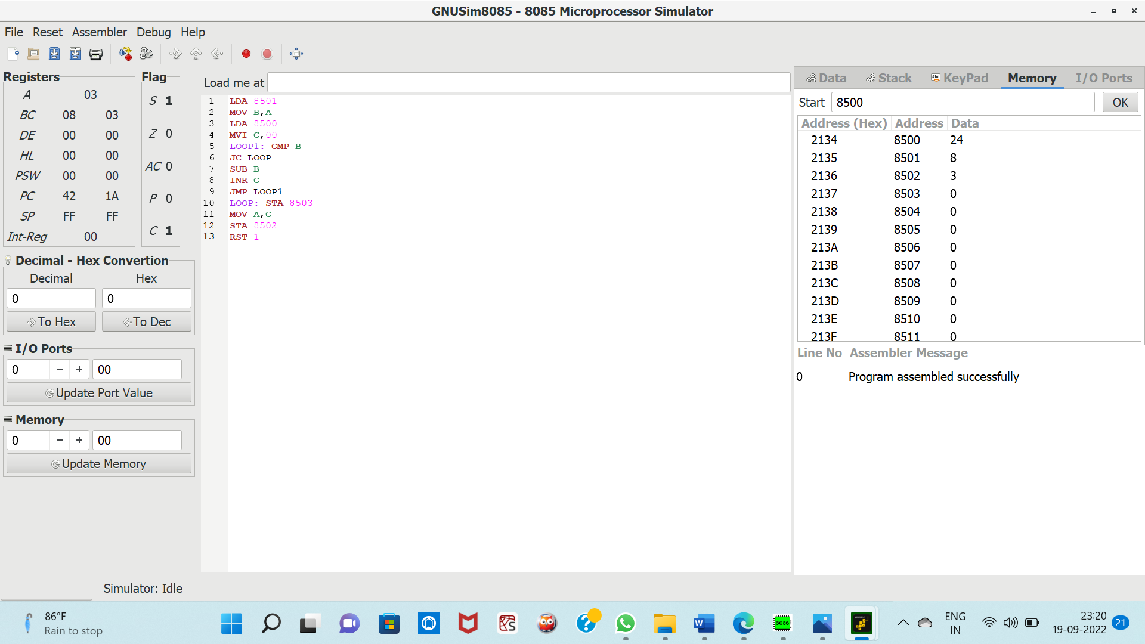

5) **Addition of two 16 bit numbers:**

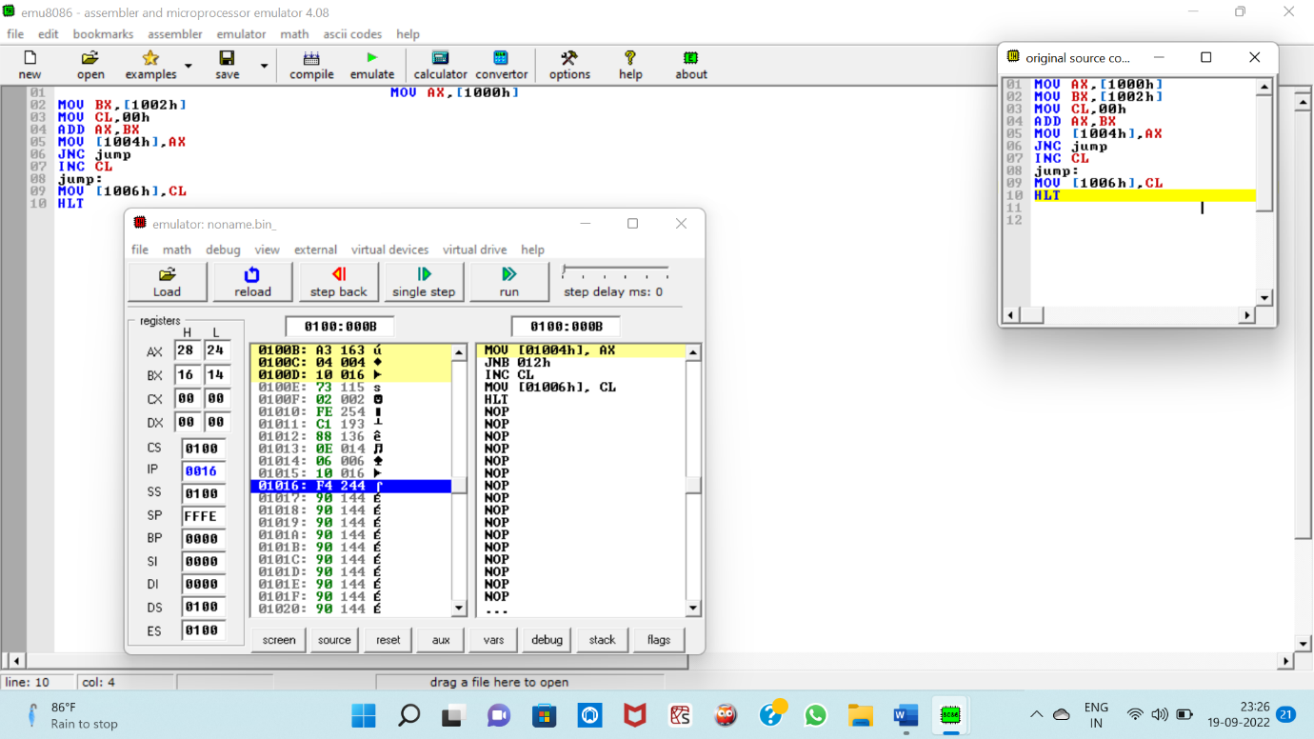

6) **Subtraction of two 16 bit numbers:**

